Designing Grid Connected Solar Electric Systems

Step One: Load Analysis: Examine the electrical usage history to determine the amount of electricity used during the year. This is an example from a utility for a commercial business. We have some usage and design information for a house at 9767 S. Holland St. Littleton, Colorado that used 6000 kWH for the entire year.
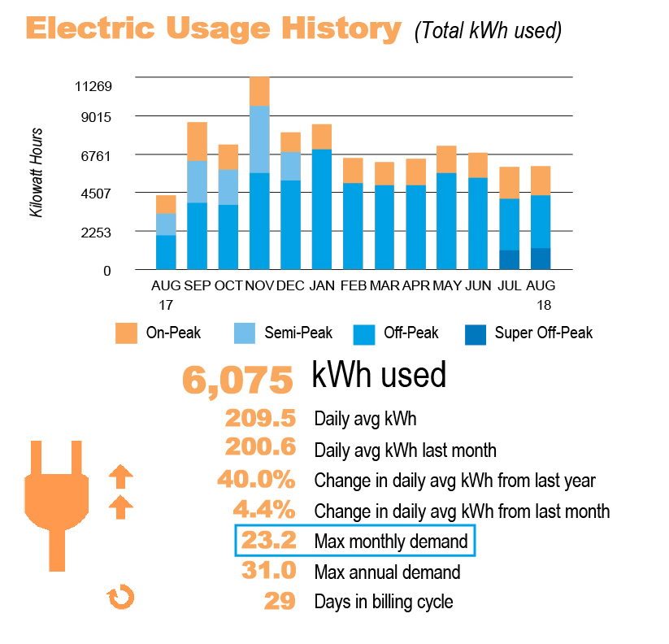

Step Two: Size Array: For a grid connected PV System the procedure is:
- Go to PV watts and enter the address of the system or city & state.
PVWatts Calculator
Next choose -Go to system info
- Use the defaults for the module type, array type, tilt and losses
- Enter the azimuth for your roof. Note- click the ? for an explanation. This is the orientation of the roof on your house. South is best or east/ west. North is typically not used.
- Enter your system size you think you will need to provide 100% of your usage. A good starting place is to size the array at about ⅔ of your annual usage. For example a house that used 9000 kwh per year would need a 6KW or 6000 Watt array
- If the annual production amount is within 10% of your annual usage proceed to step 4. If not increase/ decrease the system size.
- Extra Credit- See what a difference it makes if you plan to put the array on the north side of your roof.

Step Three: Roof Plan: Make a drawing of the roof of the planned location of the solar array. You can do this by using the measure tool in Google Earth. The measure tool is the icon that looks like a ruler and it allows you to change the units as well. It is easy to use inches as the unit as you can then divide by the module size.
Tell Your Story in Google Earth
https://earth.google.com/web/search/9767+S+Holland+St,+Littleton,+CO
We have a drawing and insolation map for this property in Colorado as an example.

Step Four: Design the Solar Array:
- Use the following assumptions
PV Modules will be 345 watt each & measure 61” x 41”
X-Series Residential Solar Panels
- Divide the size of your array by the wattage of the PV module- For example 6000 Watt/ 345 Watt modules= 17 total modules.
- On your roof layout draw in the PV Modules on the roof.
- If the roof surface can’t fit all the modules you require then use additional roof surfaces as needed. Your roof surfaces may have different azimuth orientations so be sure to go back to step 3 as needed and add all the different arrays together.

Step Five: Determine the size of the breaker used to connect the system: The total system size will be used to size the breaker to connect the inverter to a standard residential electric system of 240 VAC (Volts Alternating Current) This process is similar for string inverters and micro-inverters. For this example we will use a string inverter.
SUNNY BOY 3.0-US-41 - 7.7-US-41 | SMA Solar
The inverters available are in the following sizes. 3KW, 3.8KW, 5KW, 6KW, 7KW, 7.7KW.
Round up to the next inverter size based on your array size. For example based on the example above using 17 x 345 watt modules= 5865 Watt Array. Use a 6KW Inverter.

Inverter AC Current output = (Inverter rated power ÷ system voltage)
6000 watts ÷ 240 volts= 25 Amps
Breaker Size = (AC Current output) x 1.25- Rounded up to the nearest tens place.
25 amps x 1.25 =31.25 A
= 40 amp circuit breaker

WHY? Electrical circuits are typically designed to operate at 80% capacity.

Step 6: Choose a copper conductor for the inverter circuit
The results from step 5 will be used to find the correct size conductor for this electrical circuit. Solar professionals typically use copper wiring with a temperature rating of 90 degrees celsius. Use this part of the table to choose the correct wire.

Inverter AC Current output = 25 Amps
Wire Size = (AC Current output) x 1.25 =31.25 A
=#10 Copper Wire

Reference Material

Wire Ampacity Table
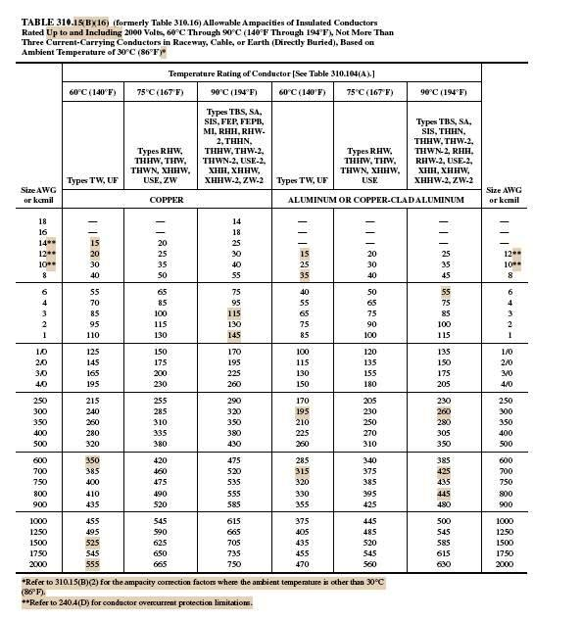

Roof Layout for 9767 S. Holland St. 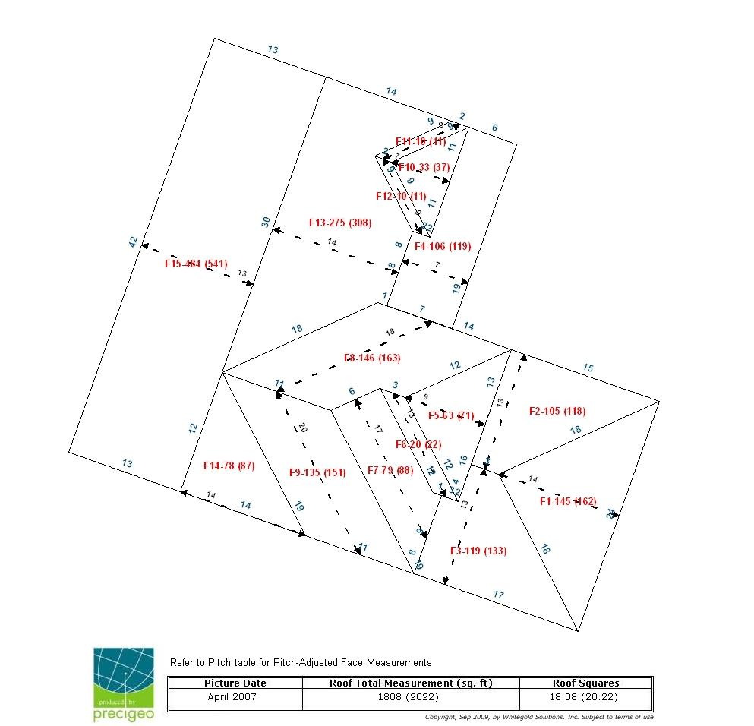
Insolation for 9767 S. Holland St. 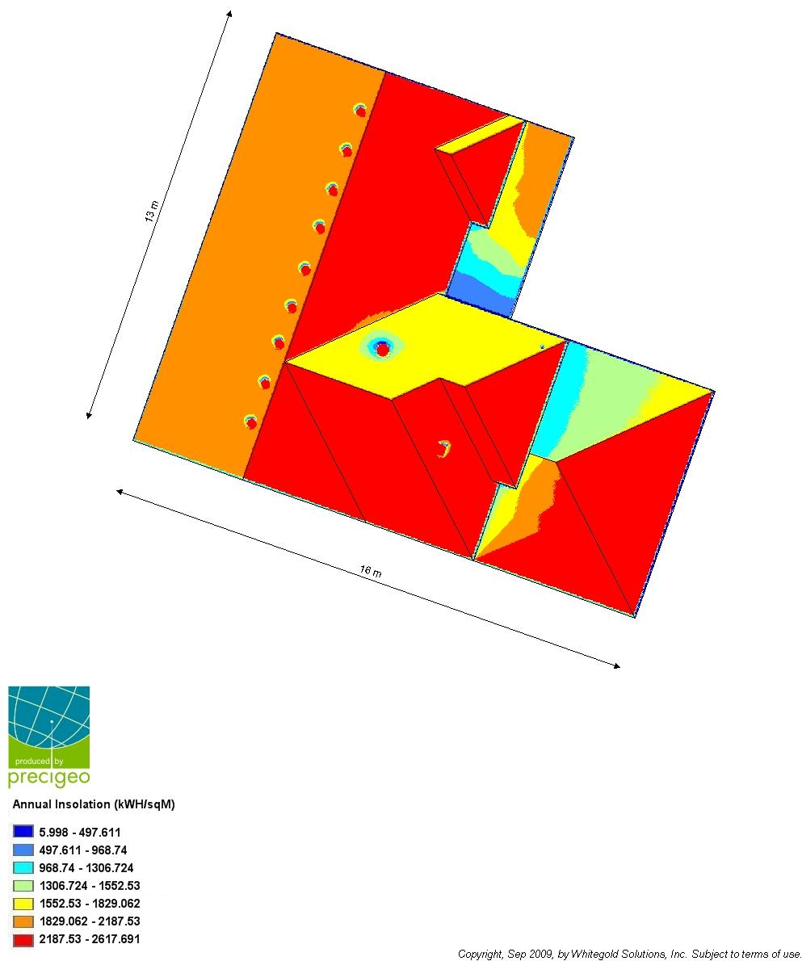

Solar Array Layout for 9767 S. Holland St.
